

|  |  |
| --- | --- |
| **Hands-on Exercise No. 2**  **DigiSkills**  **2.0 Batch-05 Wordpress** | **Total Marks: 10**  **Due Date: 17/08/2023** |

**STUDENT NAME**

**Uzma Ejaz**

**Tasks:**

**Install and Activate a Plugin**

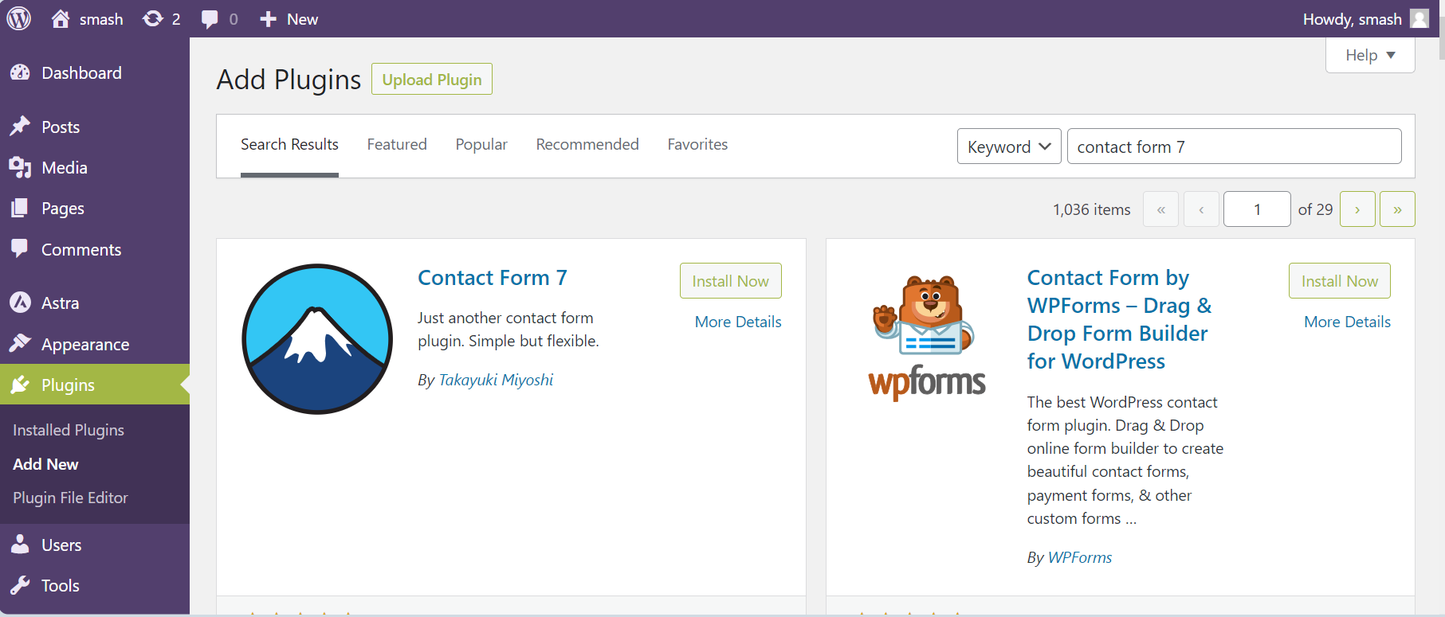



**Create a Contact Form with Contact Form 7**

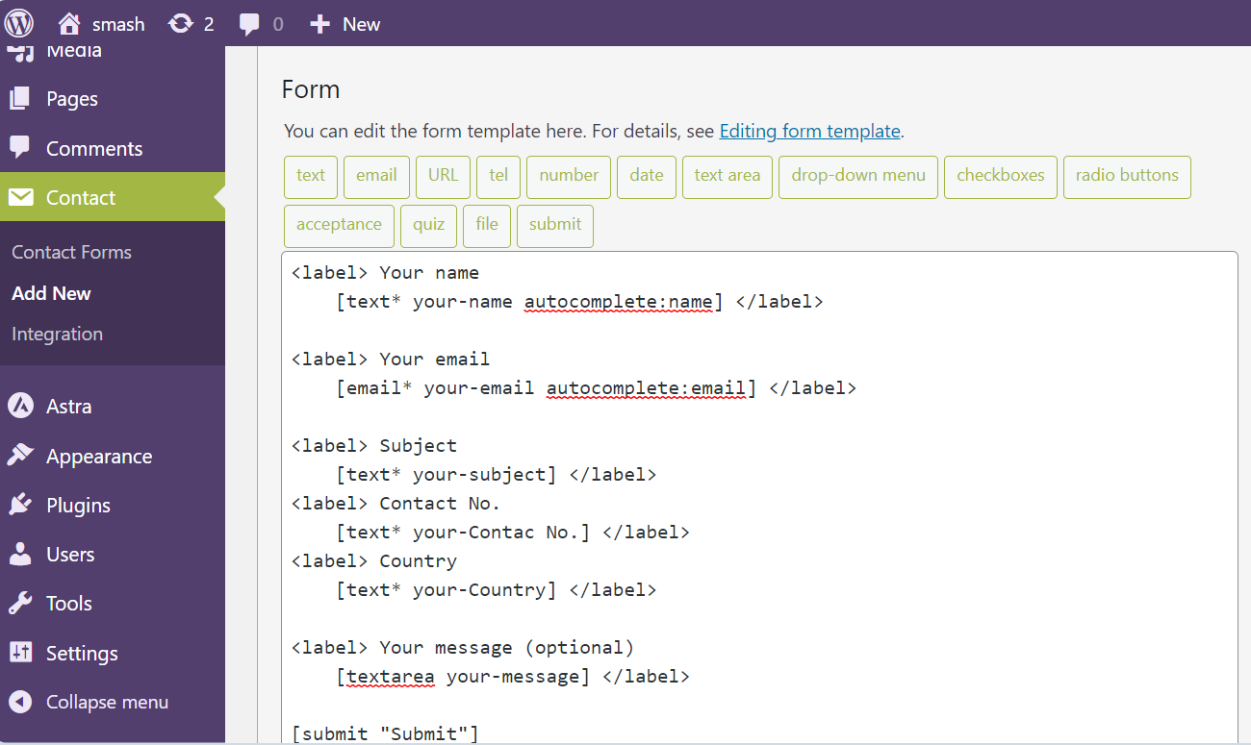

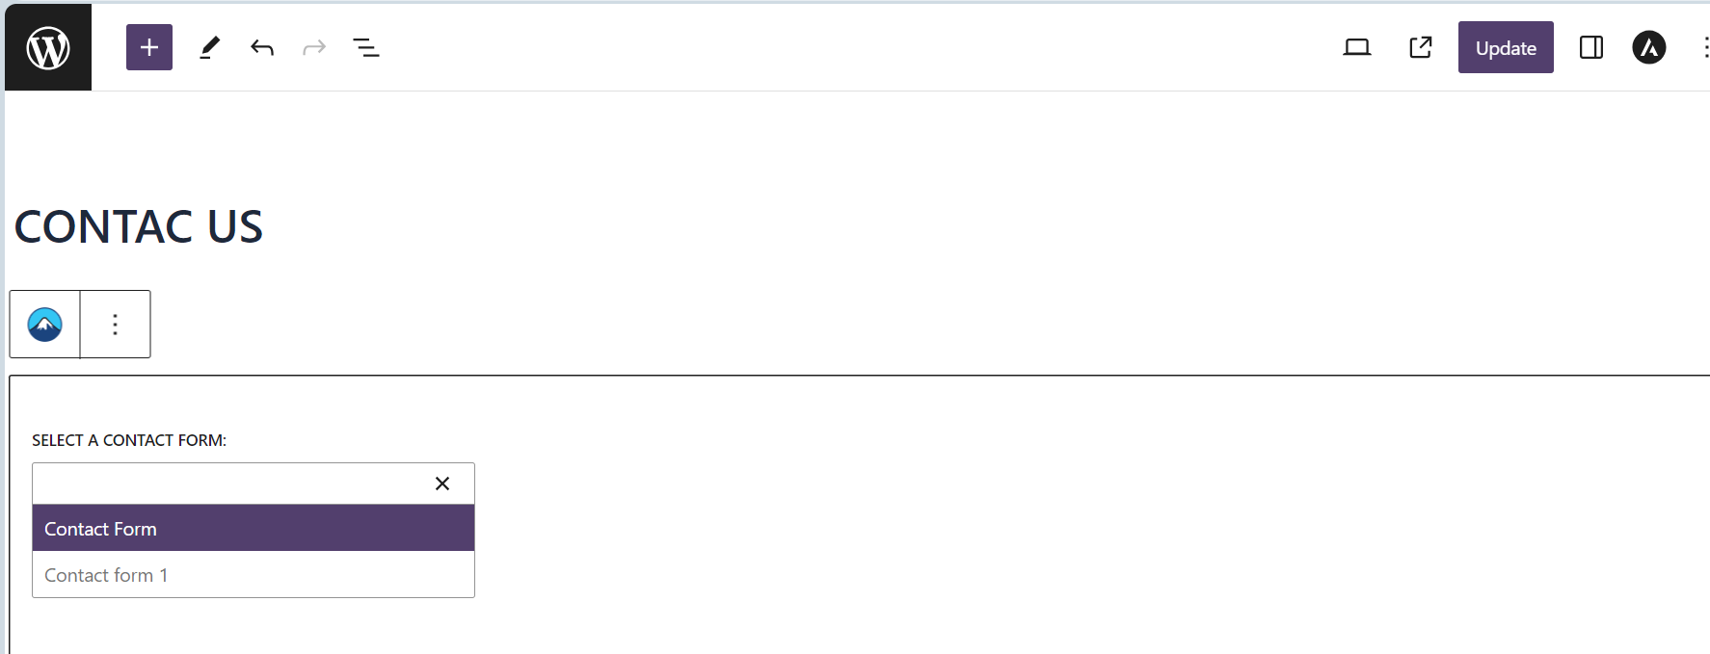

**Contact Form 7**

